Case 5-Asia-China-Shang-Zun-Bronze-1000 BCE
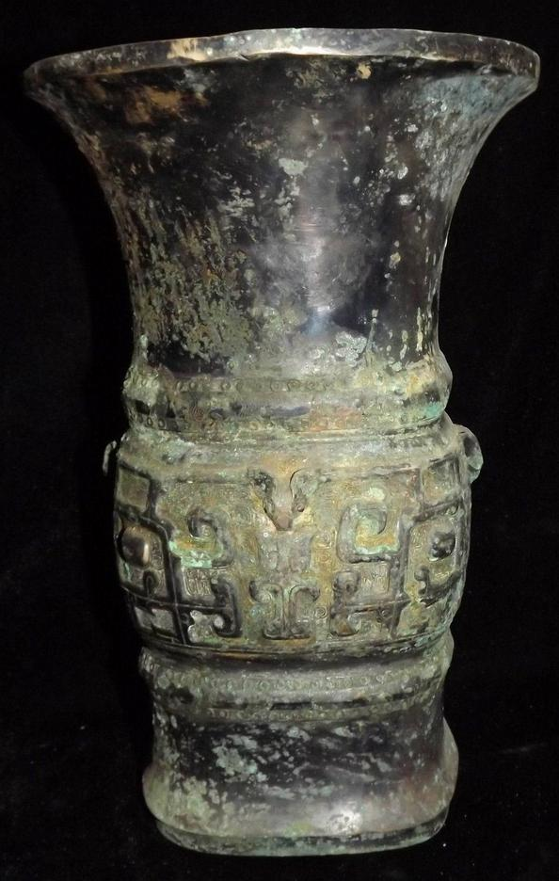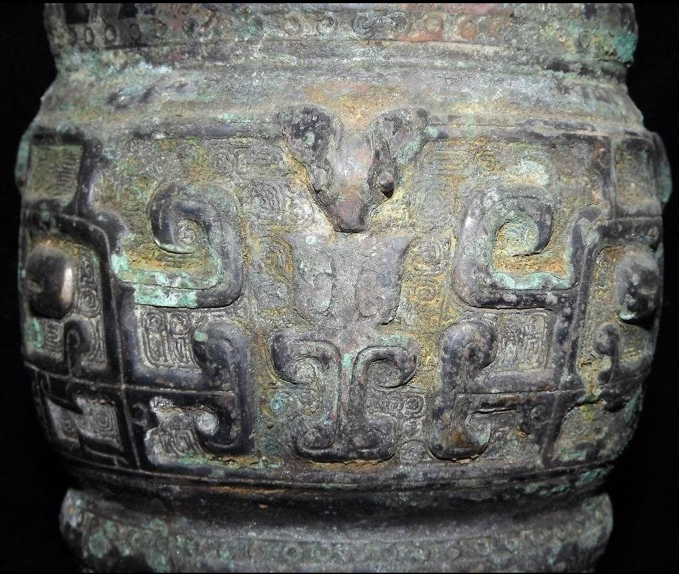

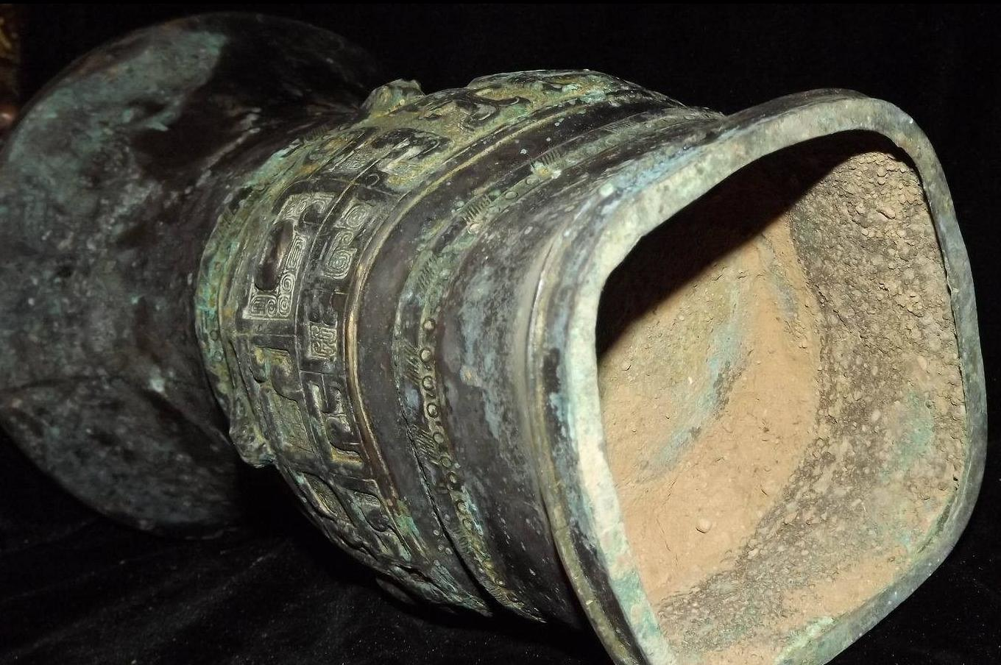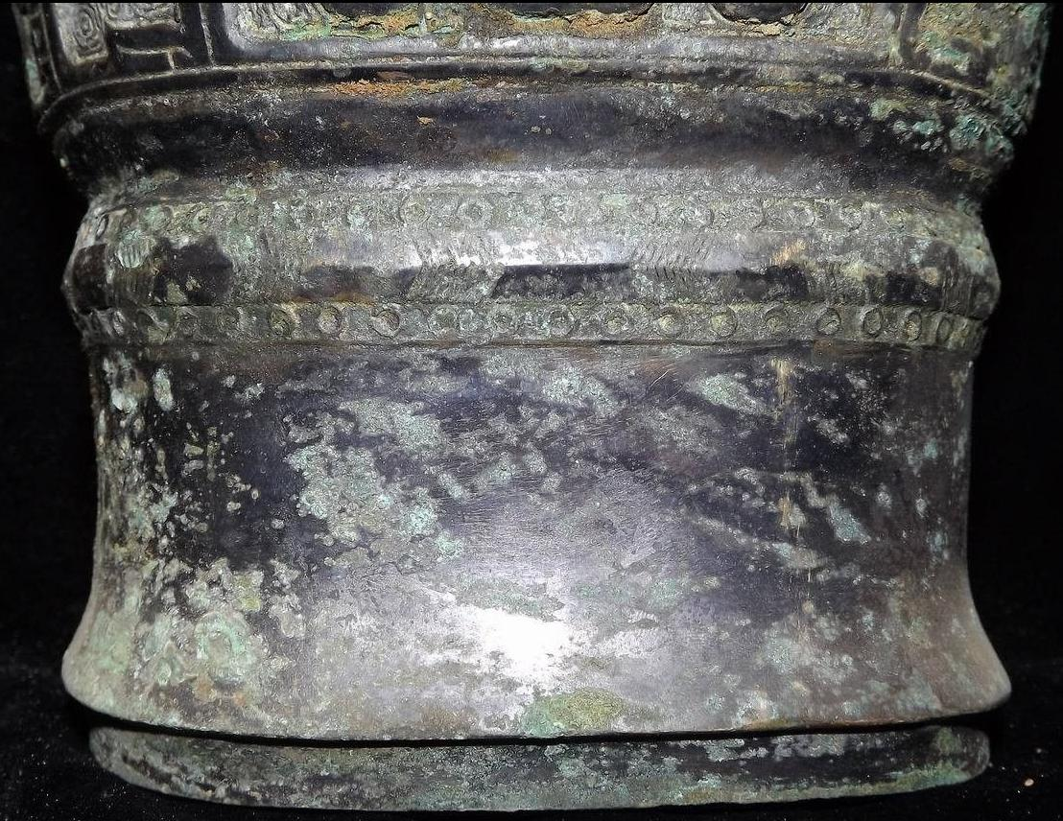
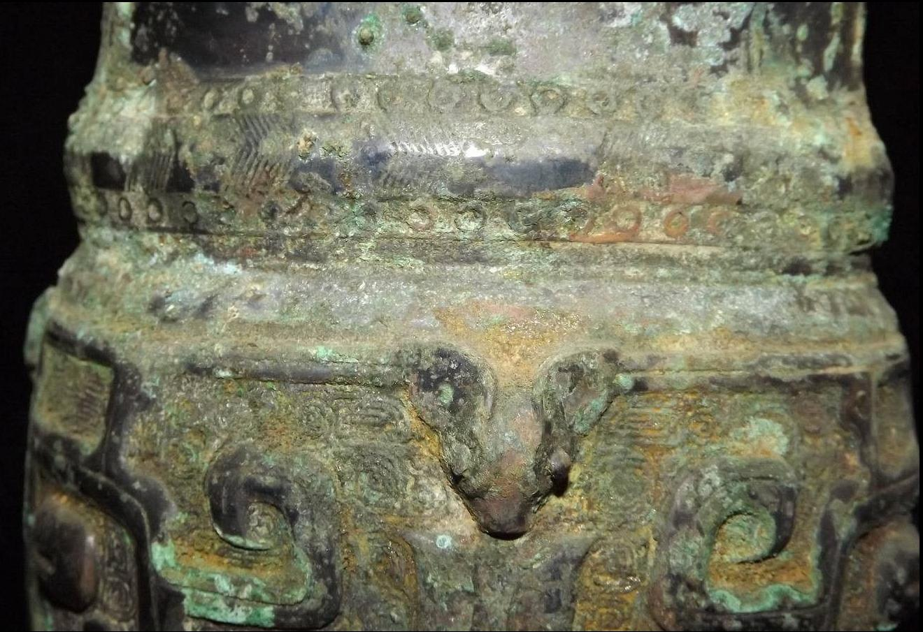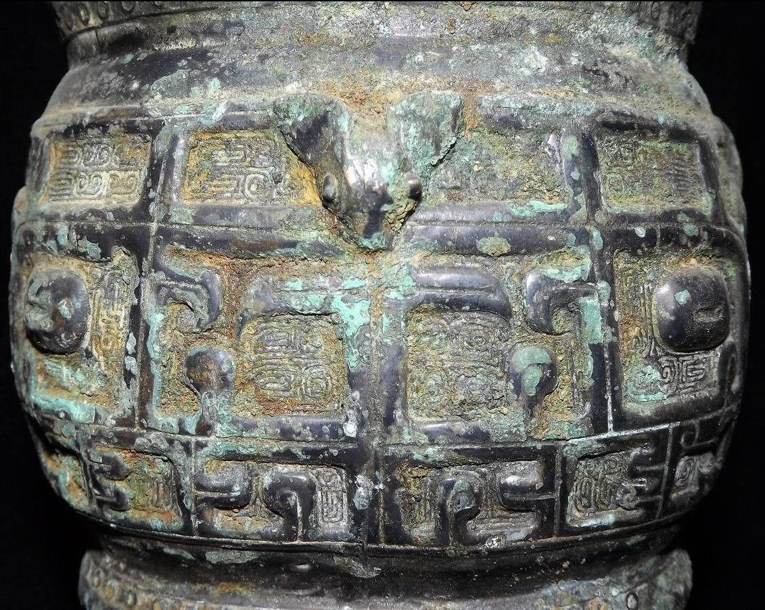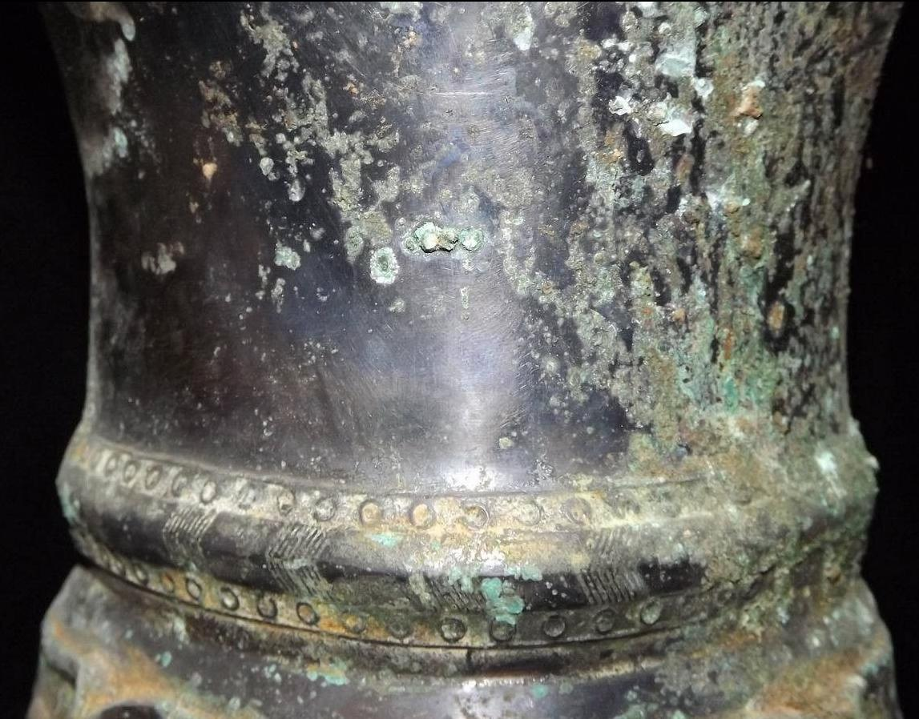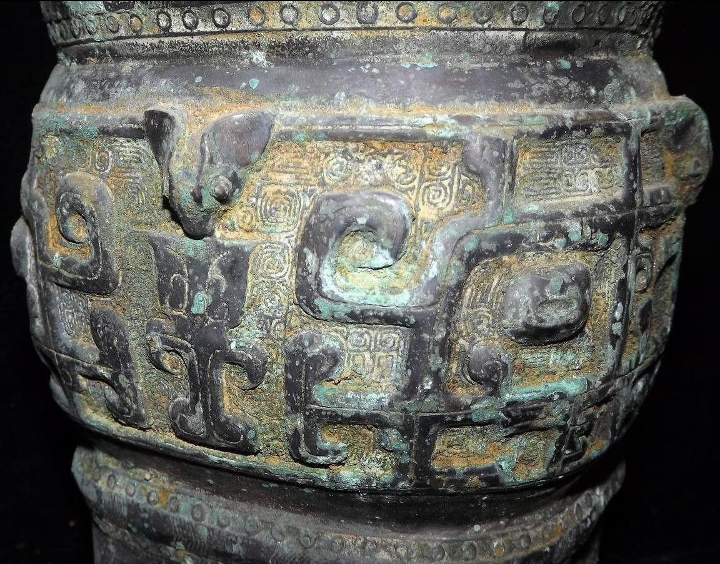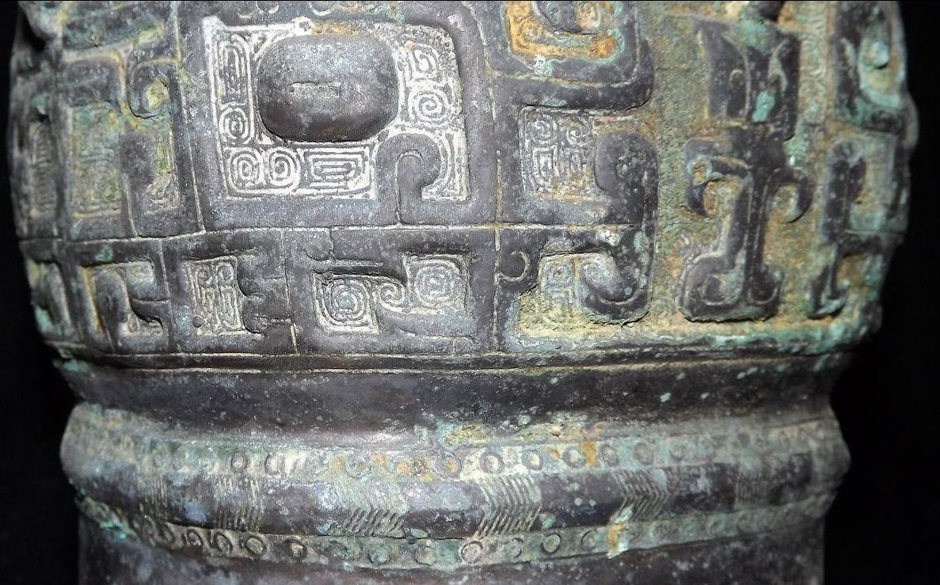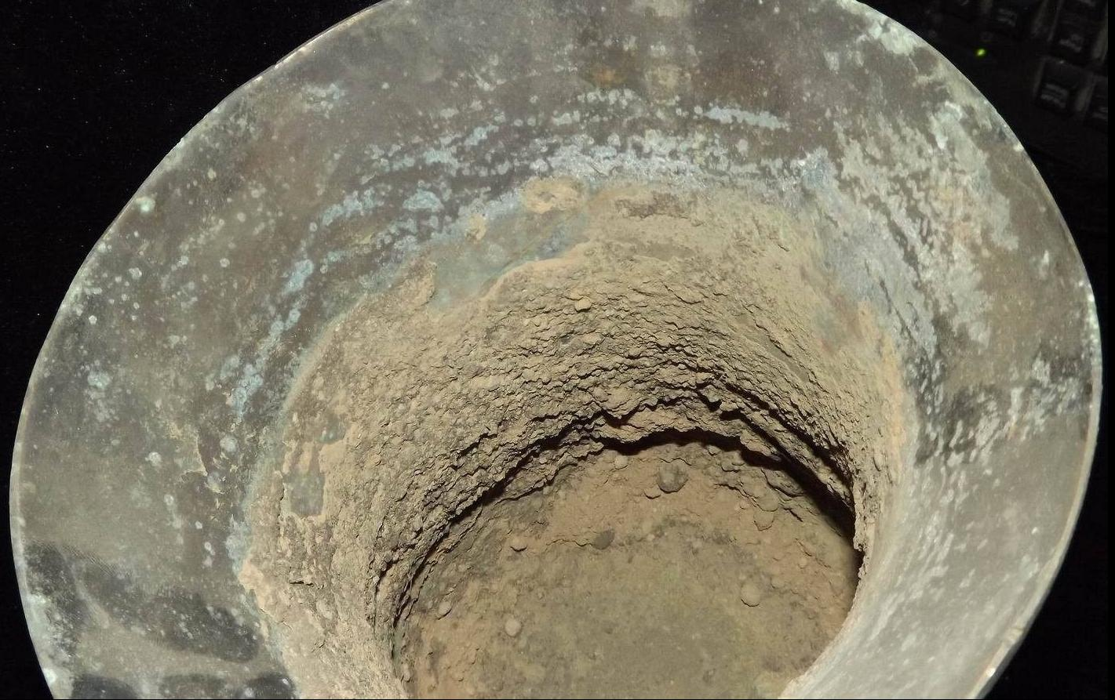

Case No.: 5
Accession Number:
Formal Label:
Display Description:
Late Shang or Early Western Zhou, 11th-early 10th century BCE, bronze Zun (Tsun), height 29 cm.
By the Late Shang Dynasty the only type of a non-zoomorphic Zun was the cylindrical vessel similar to the Ku of which this is a prime example. The transition to a plain trumpet and foot is interrupted by a central convex band with continuous decor in high relief and beautifully sculpted on a moiré background. The design consists of two large, shielded T'ao-t'ieh masks flanked by intricately crested and taloned raptors that encircle the mid-section of the vessel. These abstract birds in profile suggest a calligraphic motif giving it a certain liveliness of action that will become less abstract bird images in the mid-Western Zhou (late 10th -early 9th century BCE), while the masks act as static emblems peering frontally from the surface. A comparable example is in the Avery Brundage Collection ( d'Argencé 1977:82-83, no. XXIII).

LC Classification:
Date or Time Horizon: 1000 BCE
Geographical Area: Zhou Kingdom
Map:
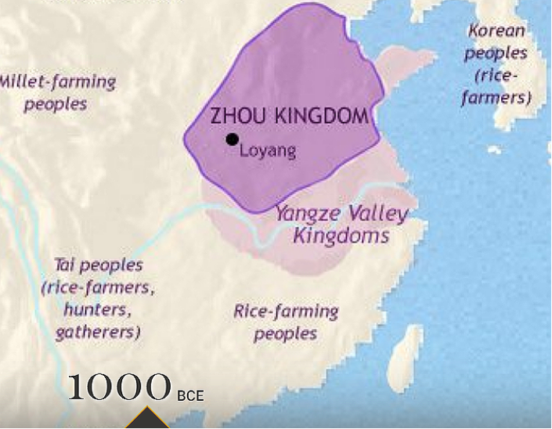
GPS Coordinates:
Cultural Affiliation:
Medium:
Dimensions:
Weight:
Provenance:
Condition:
Discussion:
References:
d'Argencé, René-Yvon Lefebvre. 1977. Bronze vessels of ancient China in the Avery Brundage Collection. San Francisco: Asian Art Museum of San Francisco.

